Name: _______________________________________________________ Period: __________

WORD TEST

- What alignment is used in this example?
This is some text. This is also some text. And yes, this is even more text. And more test still. Wouldn’t you know it, this is even more text. And look here, still more test. I can’t believe my eyes, but there is still more text here. Wow, look at this, even more text. My oh my, when will this text ever end? Okay, it looks like it’s ending now. Yes, here comes the end. And here it is.
- Right
- Left
- Center
- Justified

- Choose all of the documents you could create in a word processing program:
□ Slideshow presentation
□ Report
□ Memo
□ Spreadsheet
□ Database
□ Business Letter

- A possible spelling error is indicated by:
  - Wavy green line
  - Wavy blue line
  - Wavy red line
  - Heavy border

- Where does text go when it’s copied electronically?
  - Clipboard
  - Text box
  - Hard Drive
  - Clipart

- Information that repeats at the top of each page is called a:
  - Footer
  - Header
  - Footnote
  - Headline

- ____ are the blank white spaces around the edges of a document.
  - Ruler
  - Margins
  - Orientation
  - Views

- The indentation for reference entries on a Works Cited page are called:
  - Inverted indent
  - Tab indent
  - Normal indent
  - Hanging indent

- The numbered scale at the top of the document window is called:
  - Title Bar
  - Menu Bar
  - Toolbar
  - Ruler Bar

- When a green line appears under text it means:
  - A spelling error
  - A justification error
  - A grammar error
  - An alignment error

- Words are sometimes used incorrectly such as “two” instead of “too”. Because of this you should always:
  - Proofread
  - Spellcheck
  - Word Count
  - Not use those kinds of words

- What does “Default” mean?
  - What you change the font to
  - What the settings are when you first enter the program
  - What you can apply to the document you are working on
  - The name of the file
- Which tool might be used to suggest new words that have a similar meaning to replace the words you already have typed into your document?
  - Spell Check
  - Thesaurus
  - Grammar Check
  - Cinnamon
This is some text. This is also some text. And yes, this is even more text. And more test still. Wouldn’t you know it, this is even more text. And look here, still more test. I can’t believe my eyes, but there is still more text here. Wow, look at this, even more text.
- What alignment was used in this example?
  - Center
  - Justified
  - Left
  - Right

- What line spacing was used in the example below?
This is some text. This is also some text. And yes, this is even more text. And more test still. Wouldn’t you know it, this is even more text. And look here, still more test. I can’t believe my eyes, but there is still more text here. Wow, look at this, even more text.
  - Double
  - Quadruple
  - Single
  - Triple

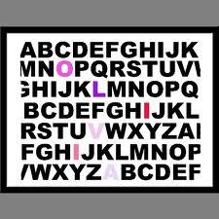
- The following is which type of page orientation?

  - Portrait
  - Center
  - Right
  - Landscape

- Documents that are pre-formatted so all you have to do is add your own personal information are called:
  - New Documents
  - Templates
  - Models
  - Structures

- What alignment was used in this example?
This is some text. This is also some text. And yes, this is even more text. And more test still. Wouldn’t you know it, this is even more text. And look here, still more test. I can’t believe my eyes, but there is still more text here. Wow, look at this, even more text. My oh my, when will this text ever end? Okay, it looks like it’s ending now. Yes, here comes the end. And here it is.
  - Left
  - Right
  - Center
  - Justified

- The following example is which type of list:
- Bread
- Carrots
- Cheese
  - Numbered
  - Bulleted
  - Stacked
  - Multi-level

- What alignment was used in this example?
This is some text. This is also some text. And yes, this is even more text. And more test still. Wouldn’t you know it, this is even more text. And look here, still more test. I can’t believe my eyes, but there is still more text here. Wow, look at this, even more text. My oh my, when will this text ever end? Okay, it looks like it’s ending now. Yes, here comes the end. And here it is.
  - Left
  - Right
  - Center
  - Justified

- Label the following parts of the table:
A
B
D
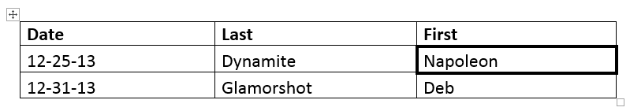
C

________ ROW ______ SELECT ENTIRE TABLE

________ CELL ______ COLUMN

